* GENERAL SEARCH

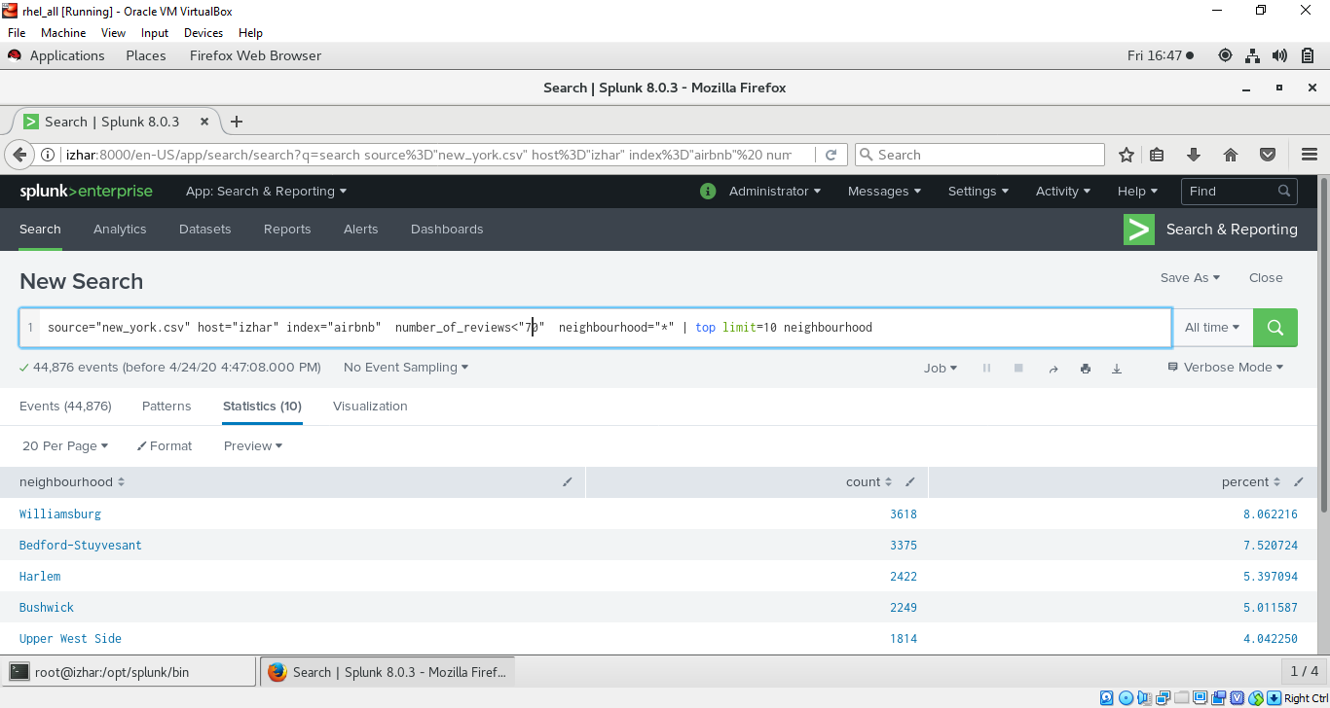

* CLICK ON SAVE AS -> REPORT

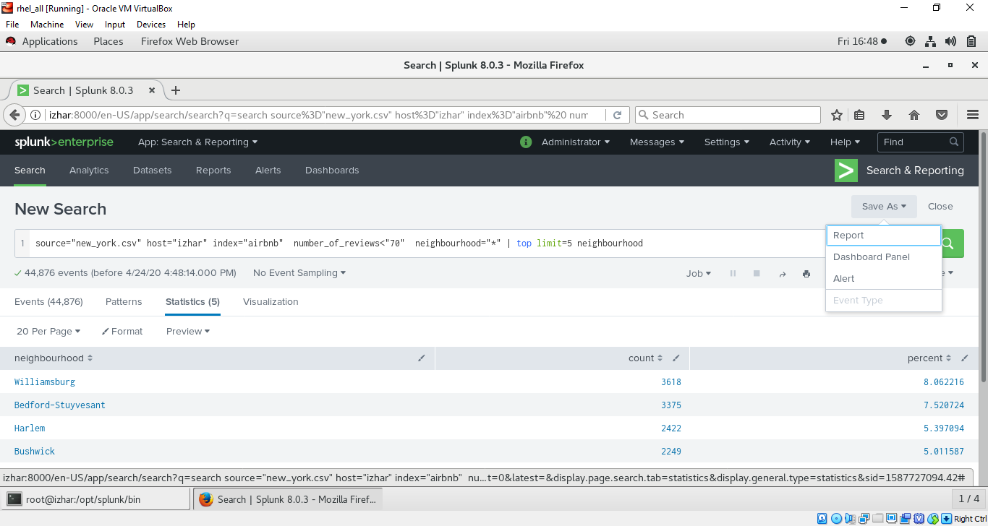

* Give tittle, description choose time range yes 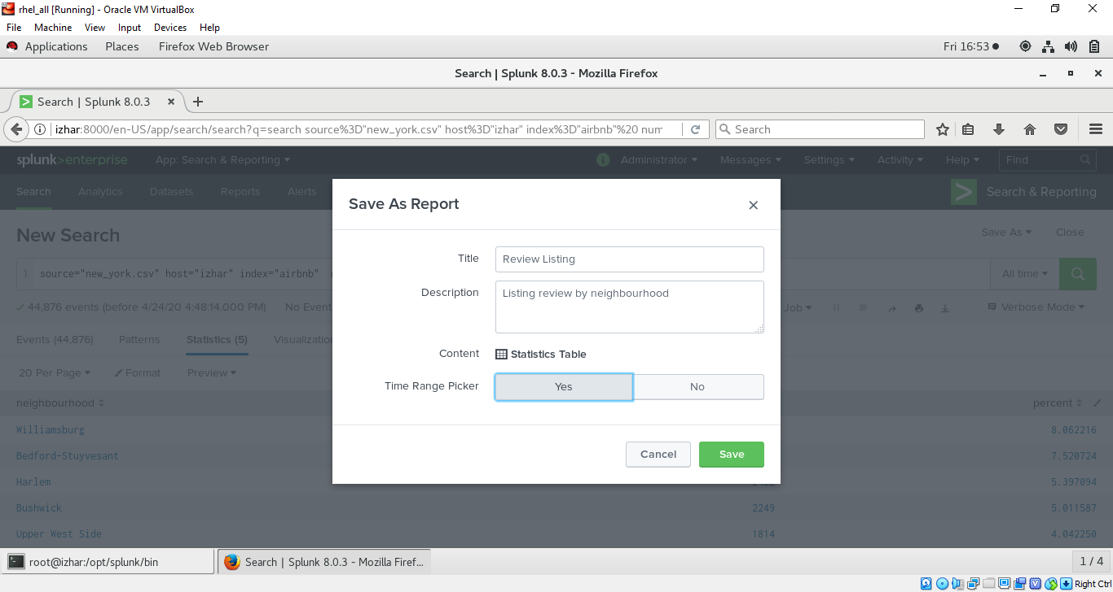
* Click on continue editing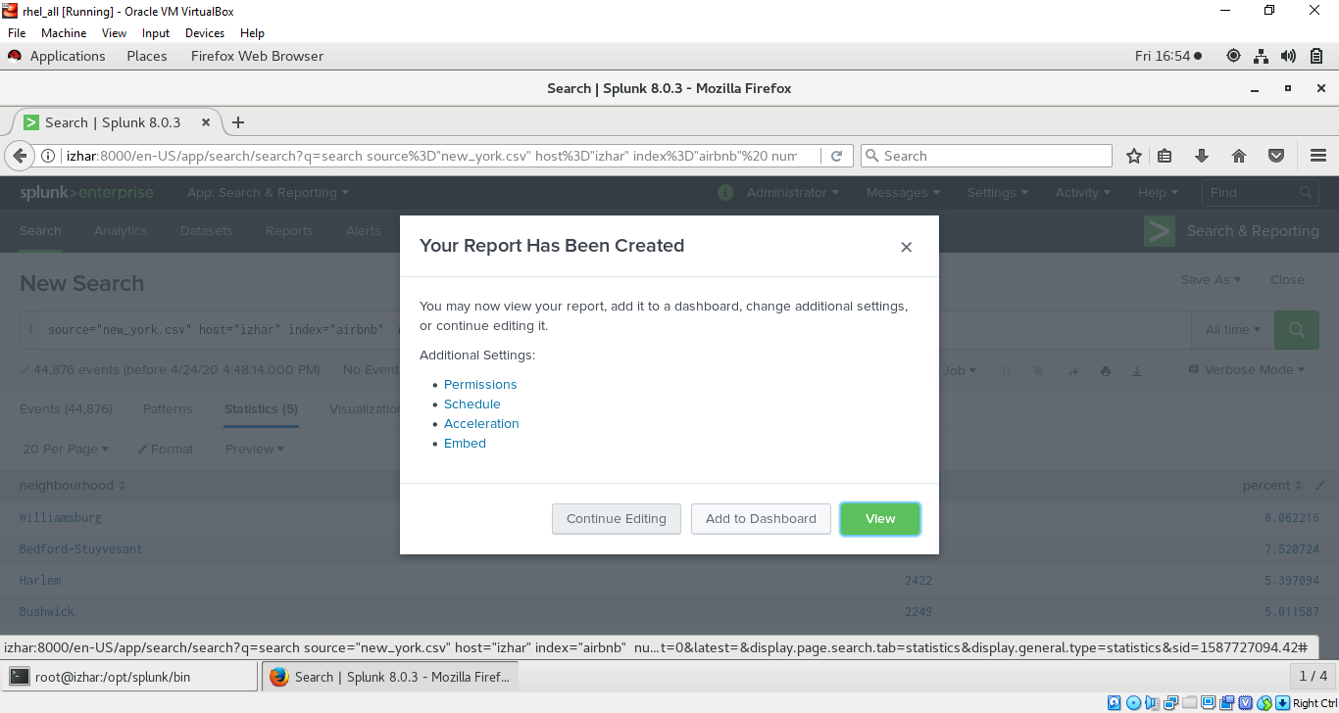
* Choose visualization according to your own choice 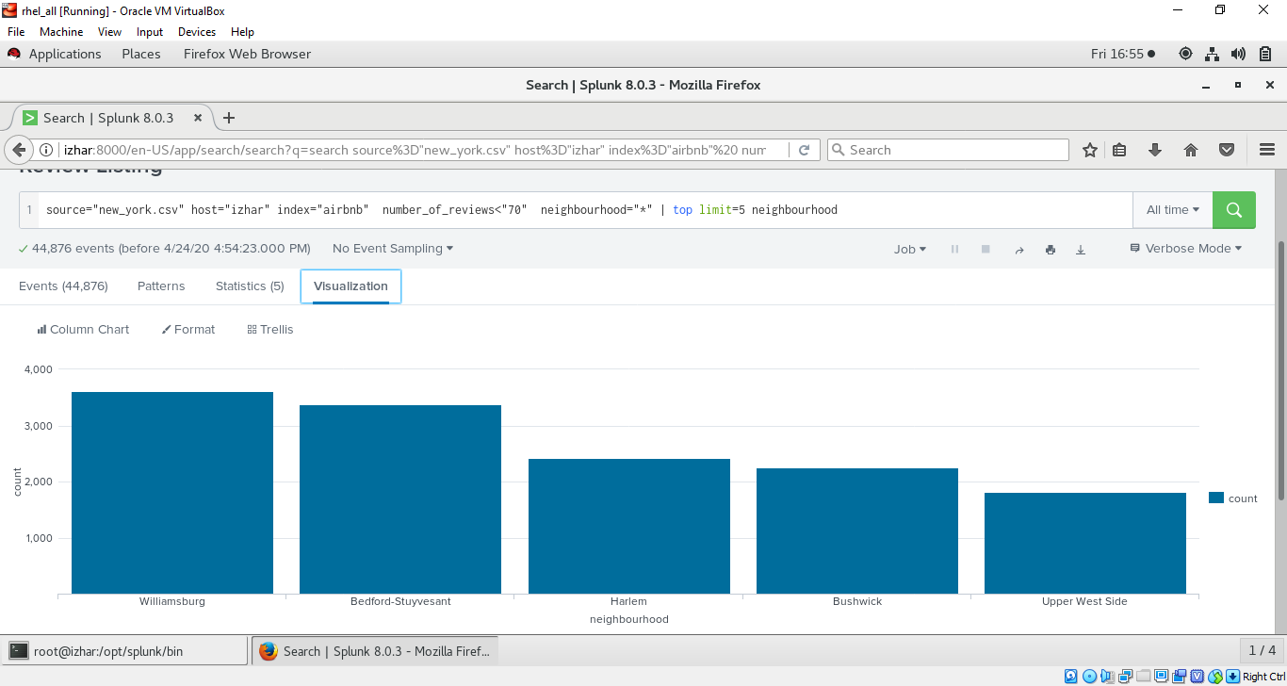
* To check the permission click on review 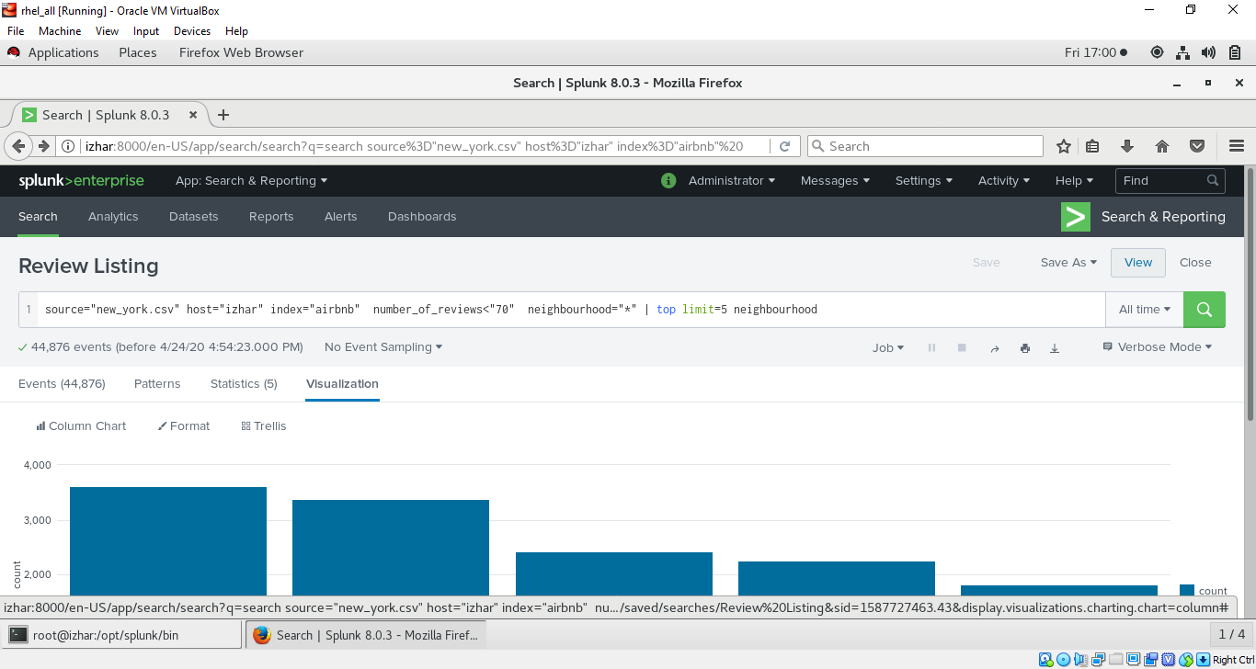
* Then click on edit -> edit permission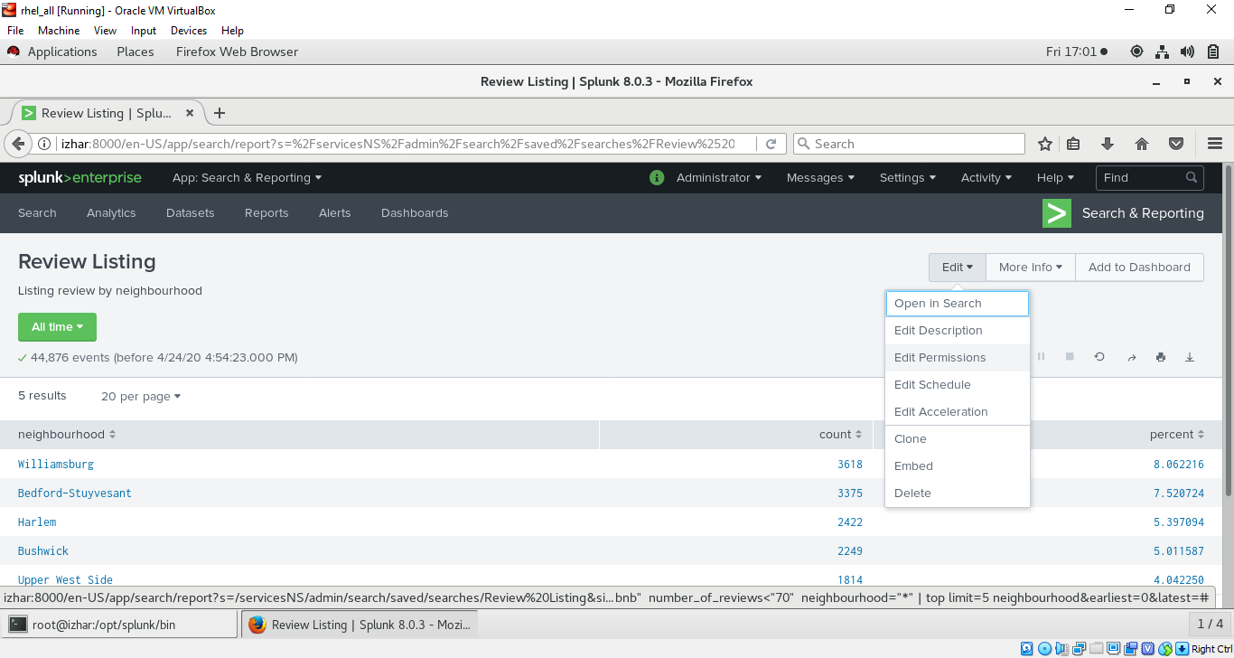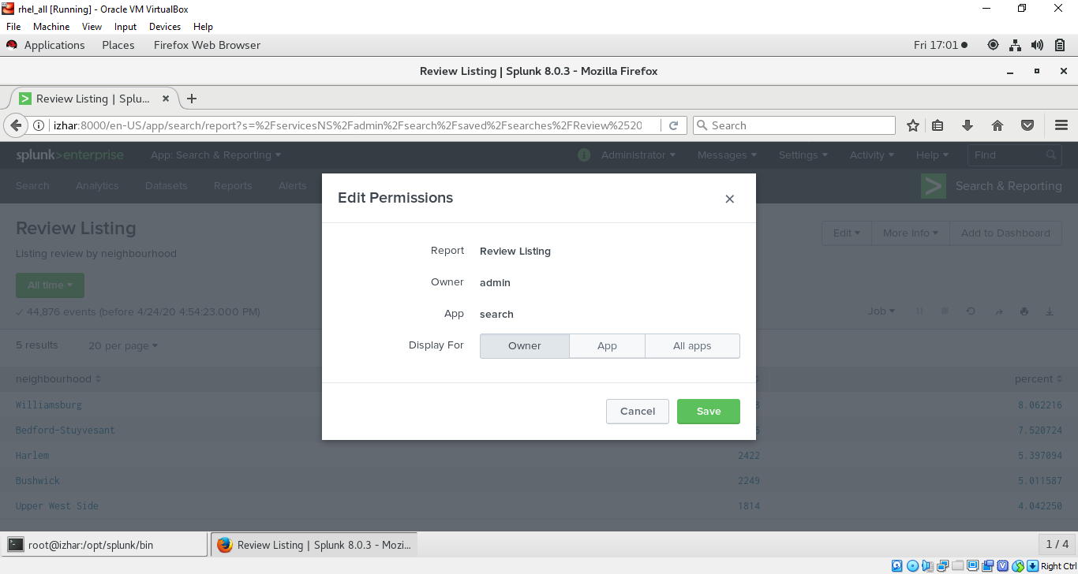
* Report Permissions (go to report option on top tool bar see your report and click on edit) 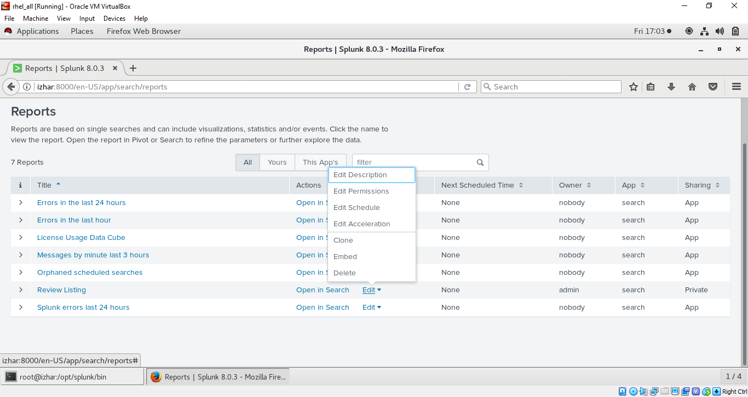
* Click on app and give read and write opton to users on your choice listed in your optoins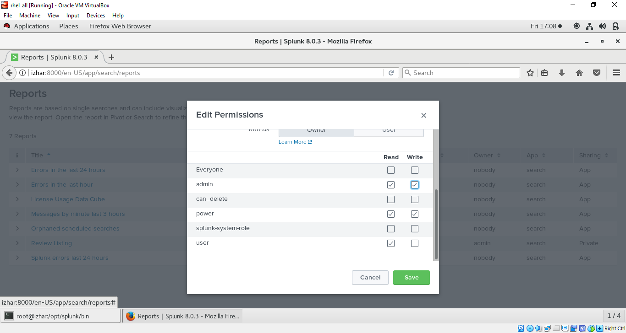
* Cloning report (by other user say a user Tom has logged in and want to access the report so he got an access as we provided in previous demo) 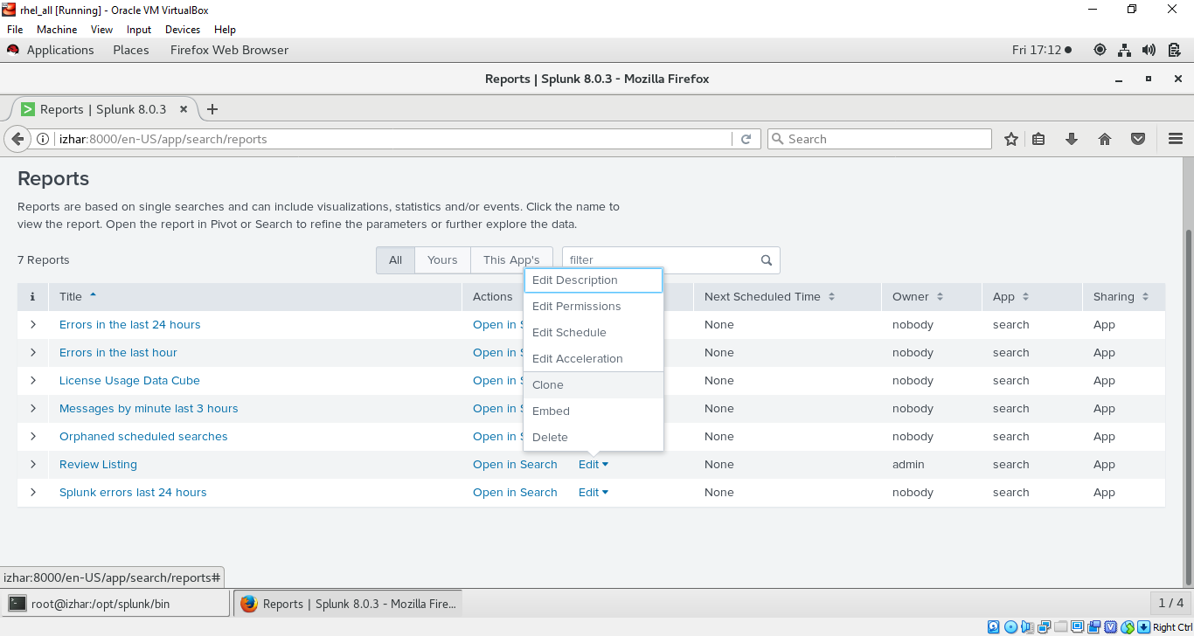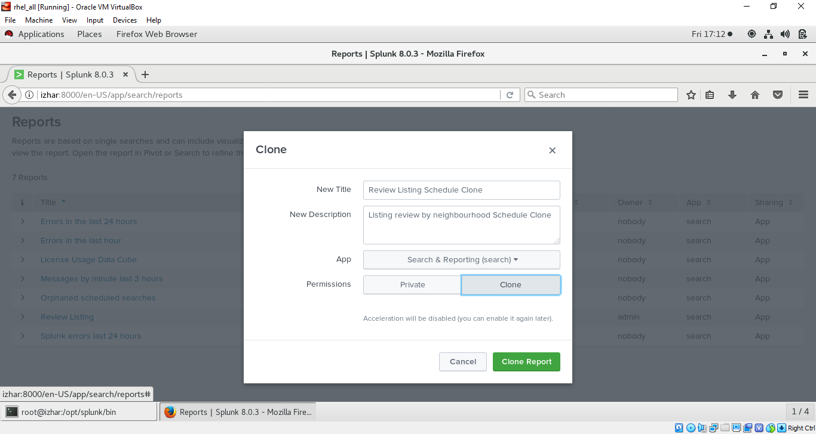
* Scheduling report click on schedule 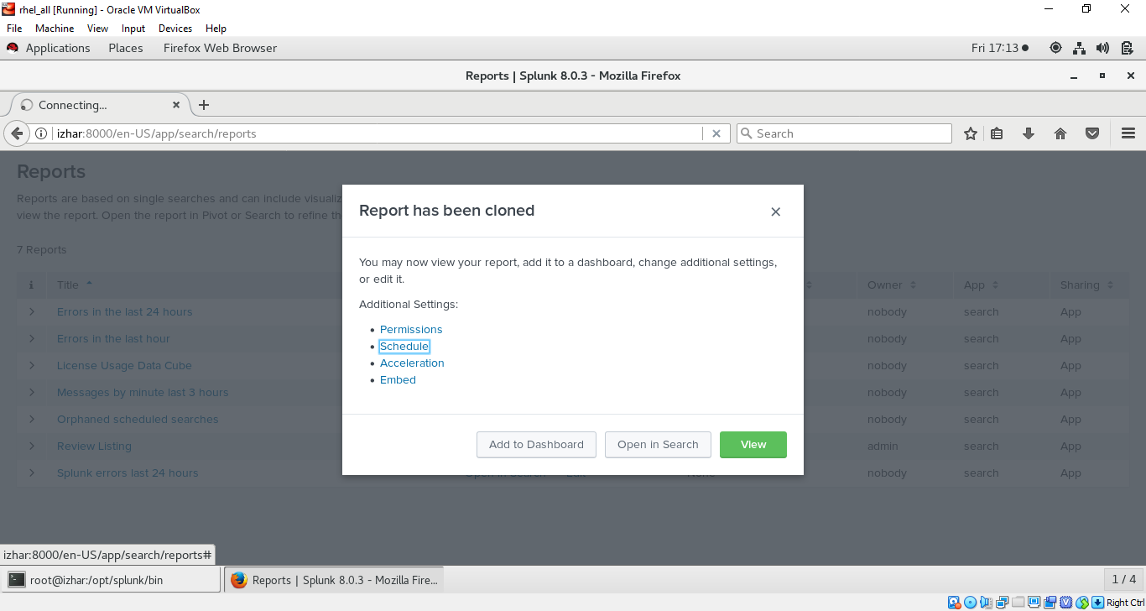
* Provide schedule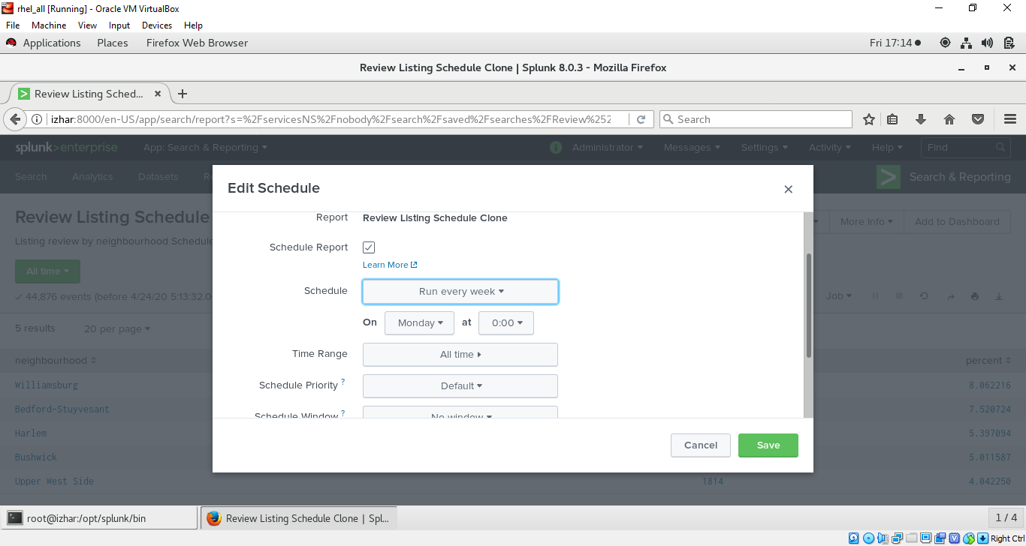
* Now again go to report option and search for your report 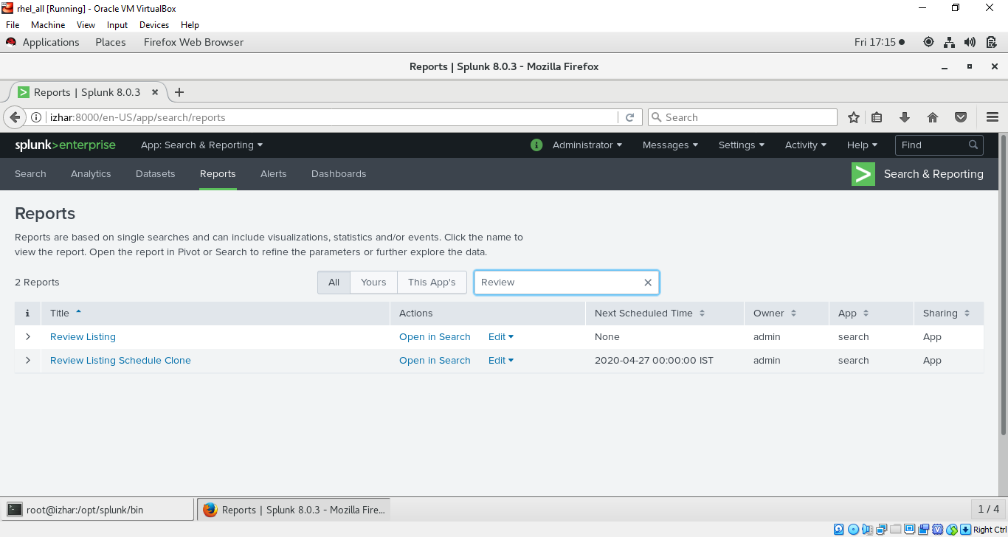
* SPLUNK DASHBOARD (click on dashboard option in tool bar and then click on create dashboard) 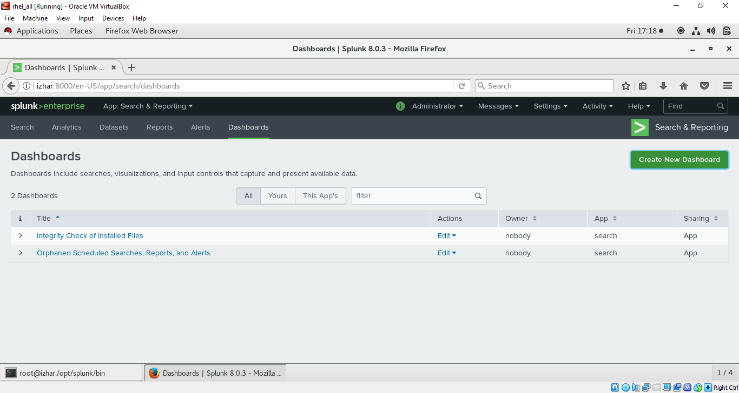
* Give information and keep permission private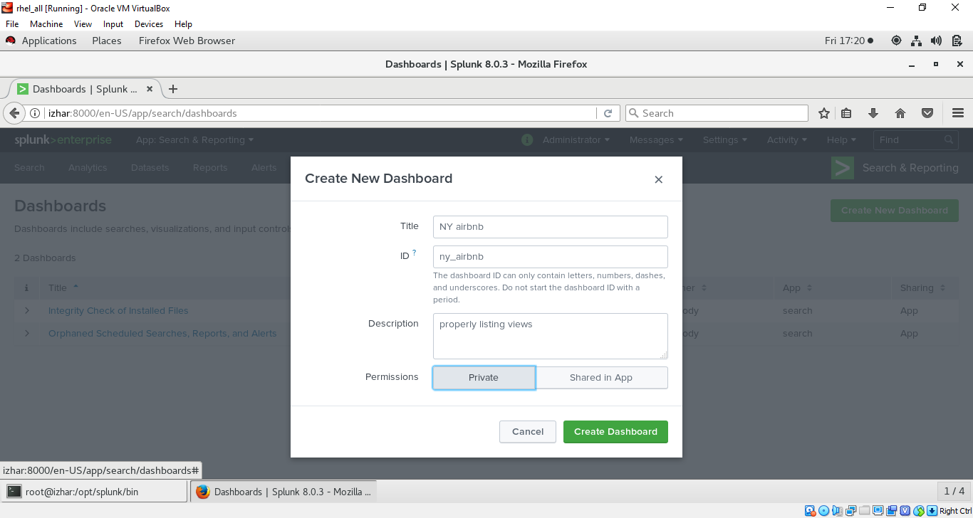
* You can switch on dark theme and then click on save 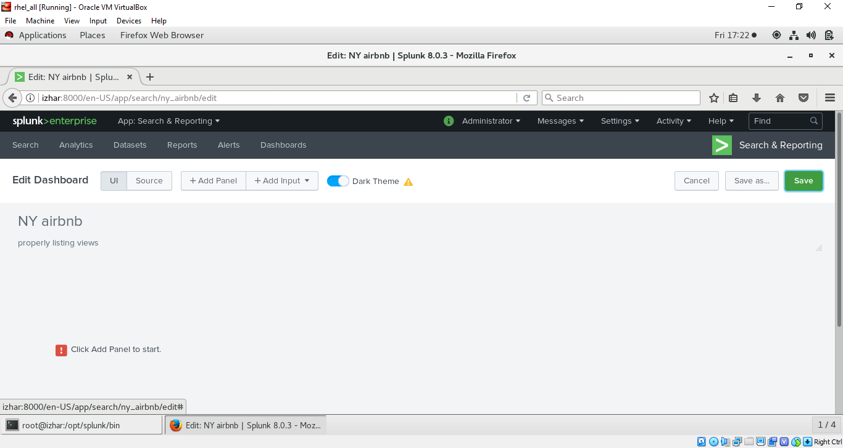
* Now to add on dashboard click on edit 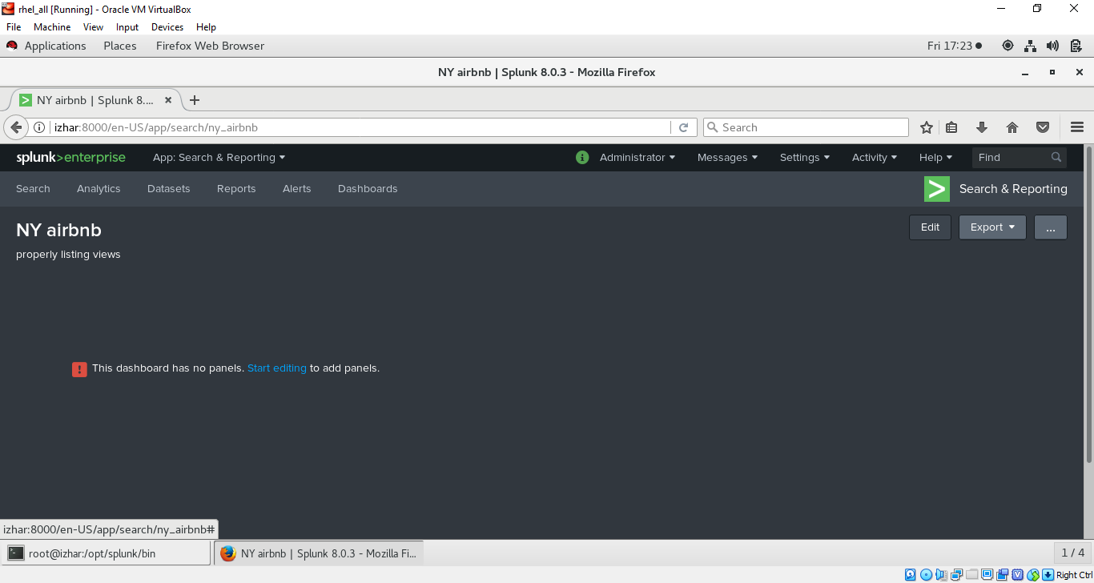
* Click on add panel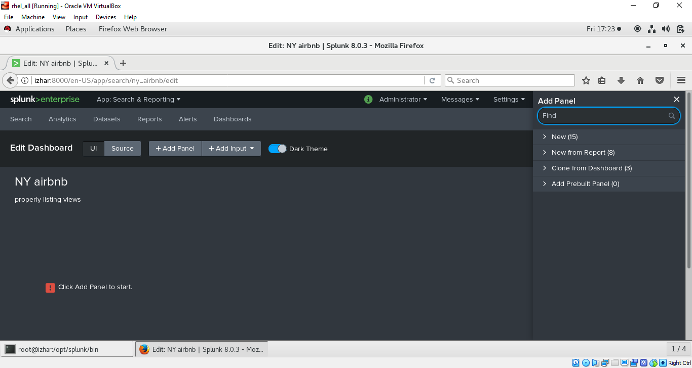
* Click on new from report to add report we have created then choose report then click on add to dashboard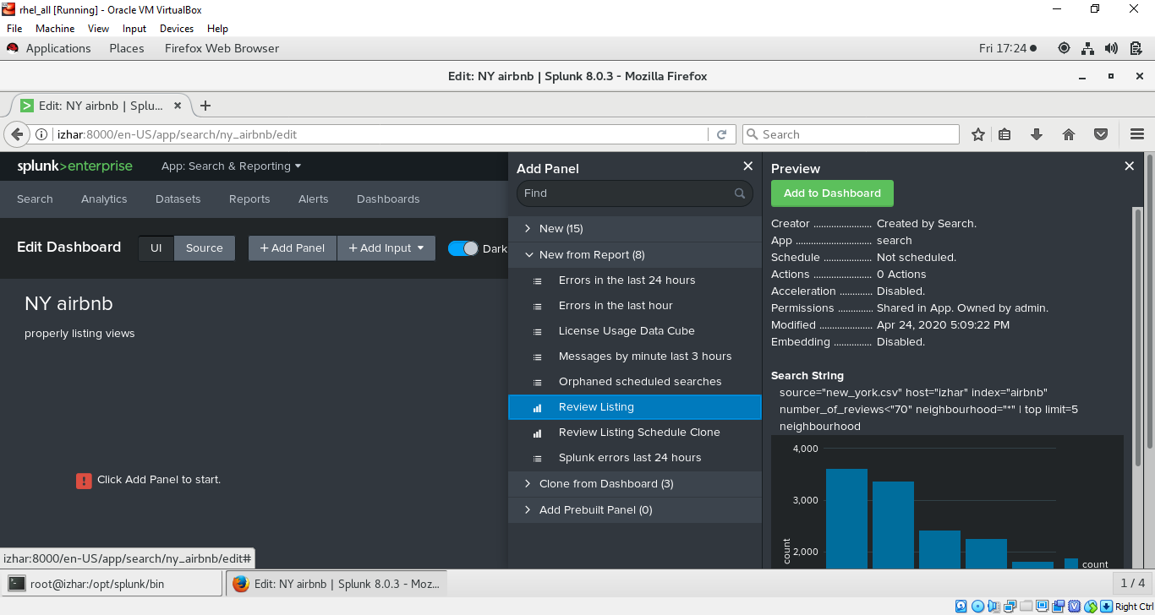
* Now save the dashboard 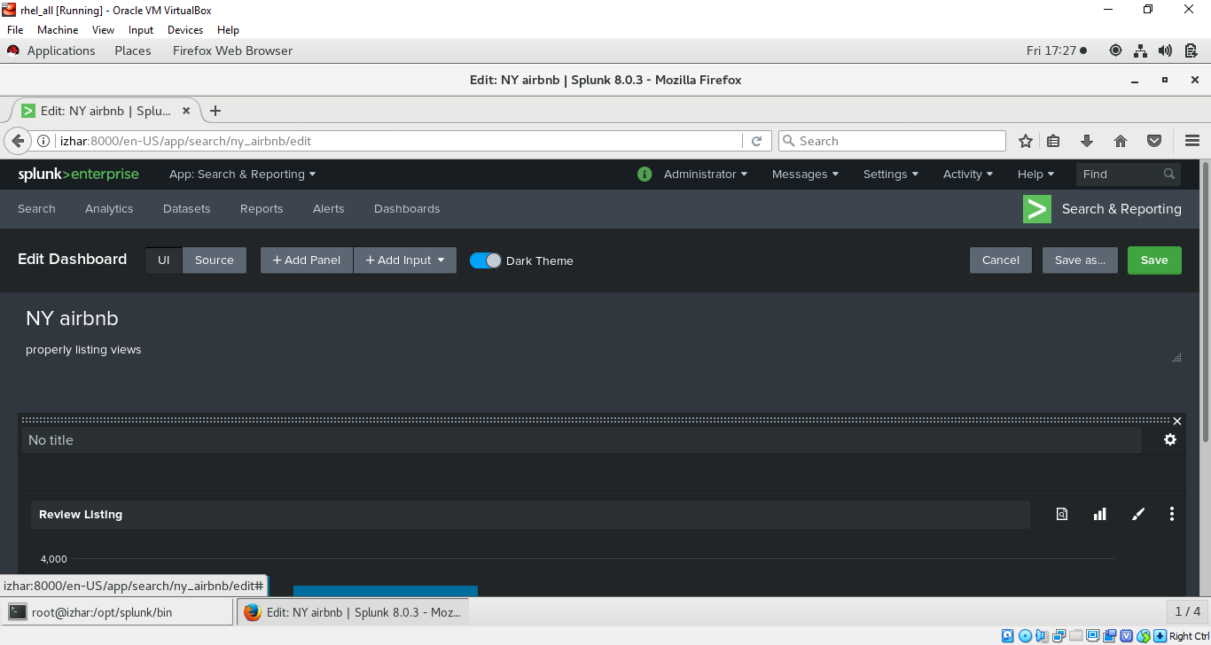
* After saving my report data look like this on dashboard your might be different as you created your report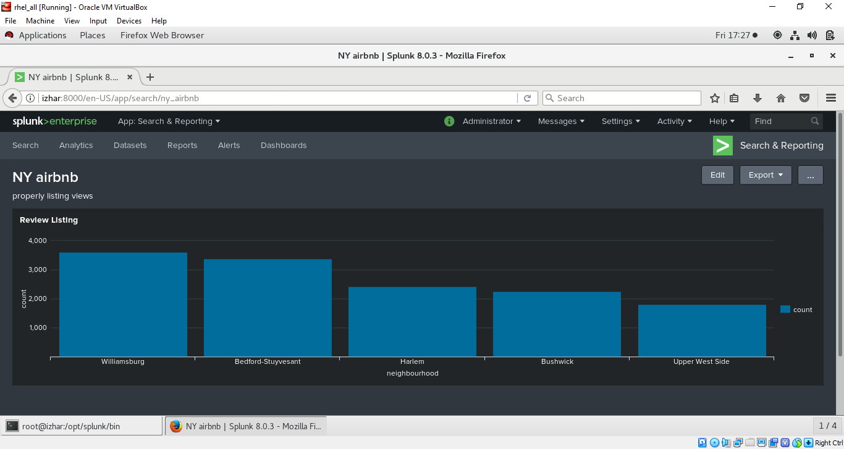
* No go back to home page 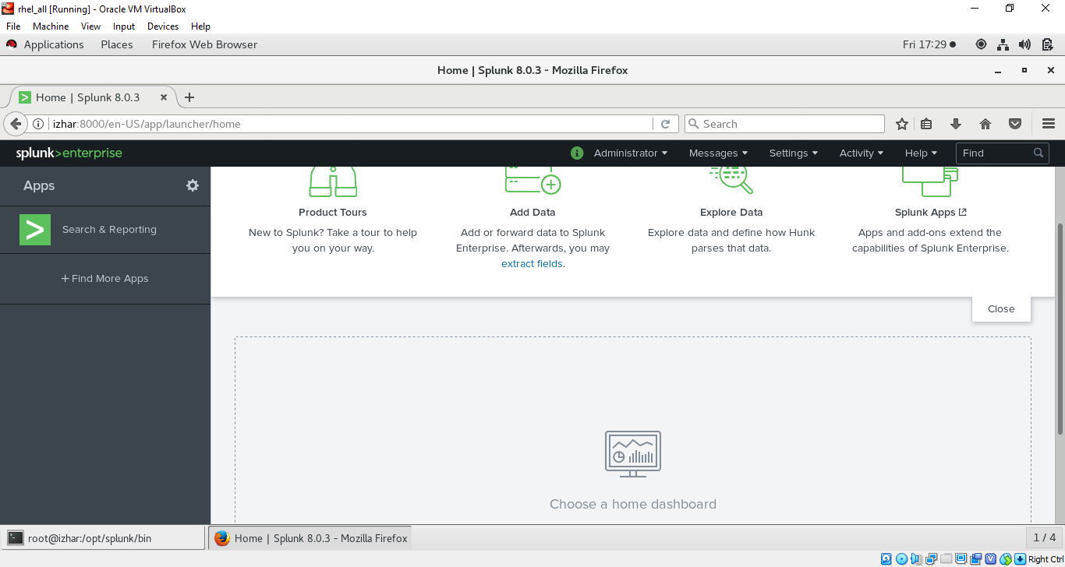
* Click on choose home dashboard and select the dashboard we have created 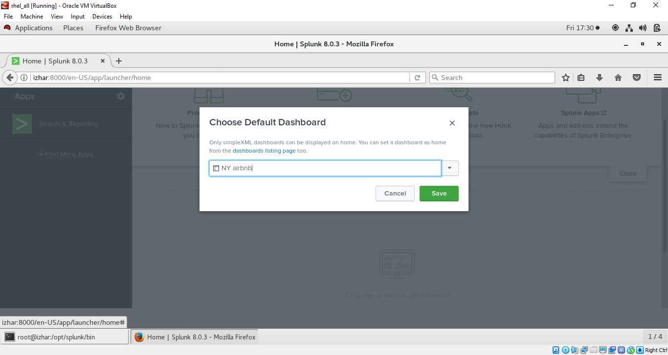
* output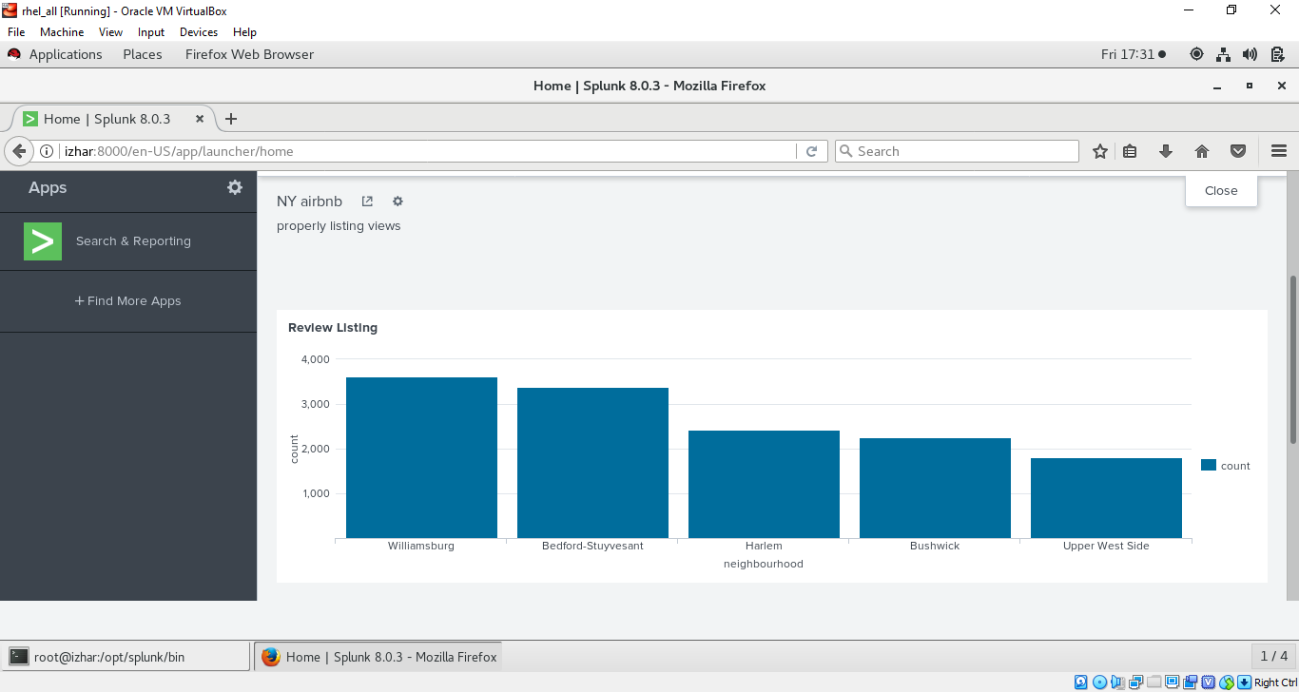
* demonstrating more :- create a new report (as you already know how to create it) 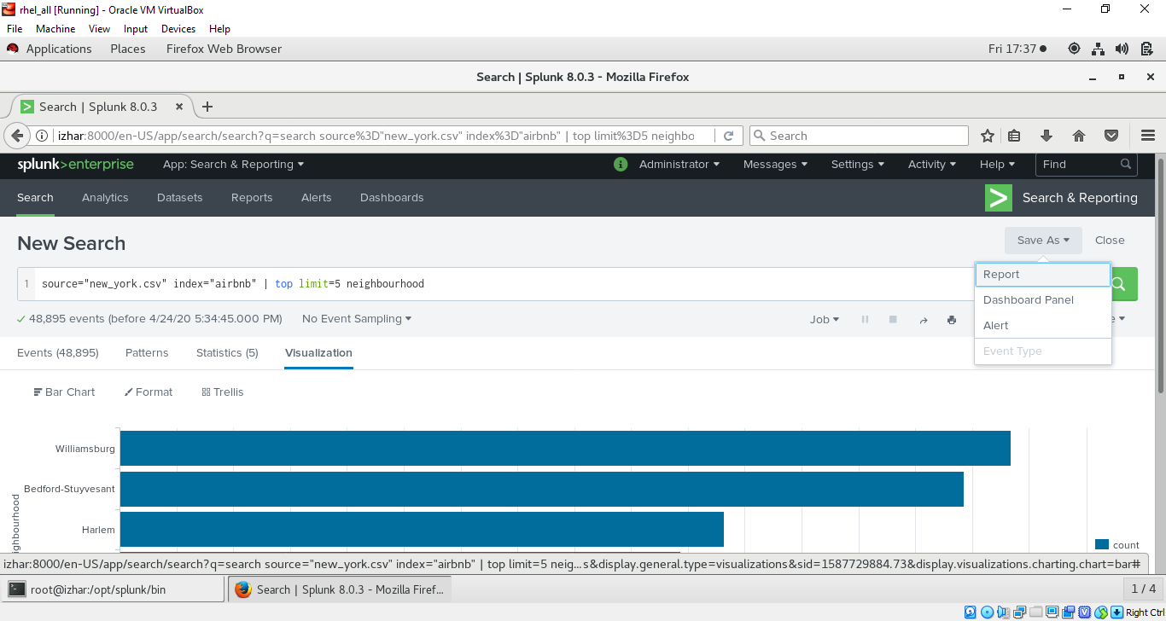
* save this as report and then go to dashboard choose NY airbnb and then add panel choose the report we have created and you will see the already one dashboard in it you can drag report up down left and right similarly you can add many report to dashboard i have added one more related to room_type and in pi chart visualtization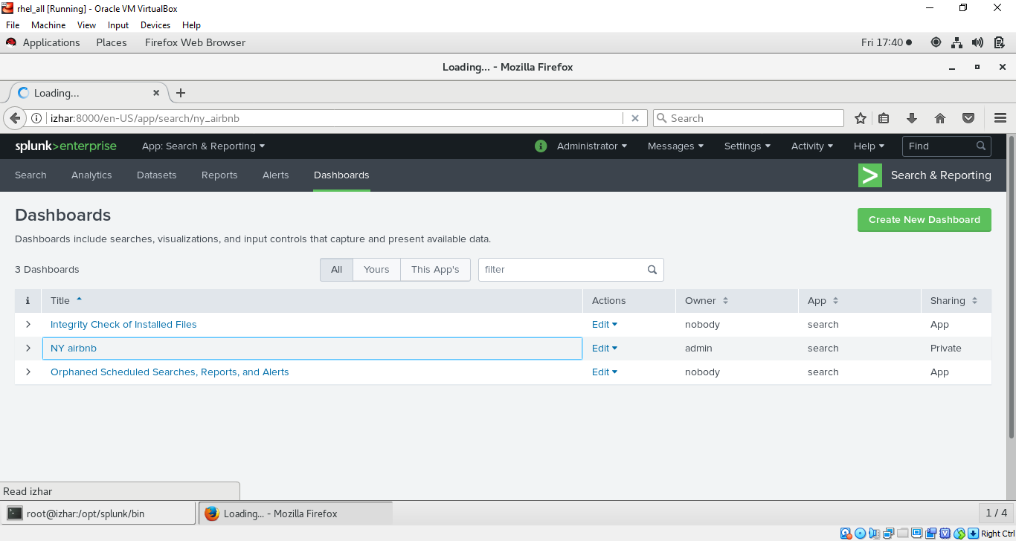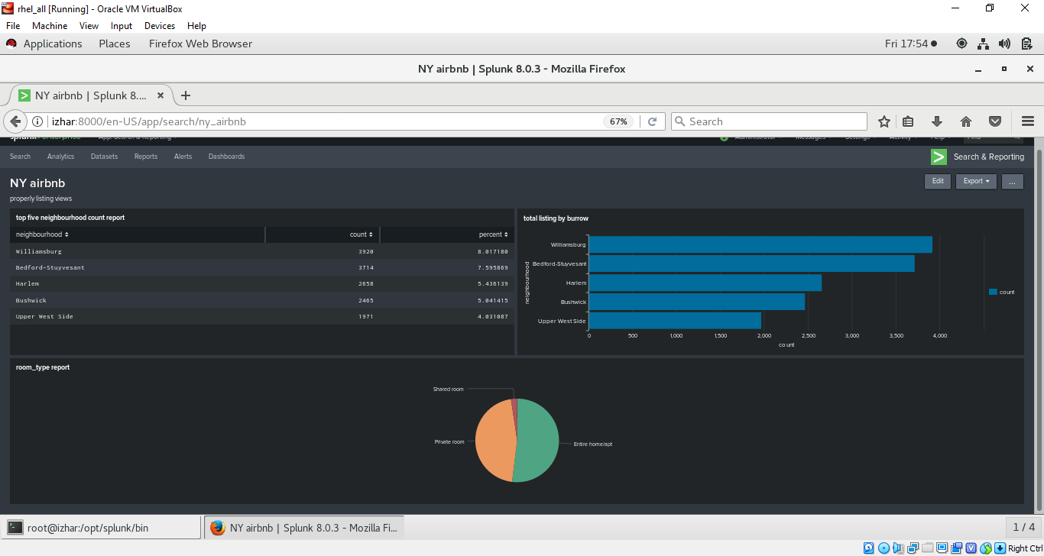
* the above shows my final dashboard with three reports on different parameters
* Now when you go to splunk home page you will see this dashboard 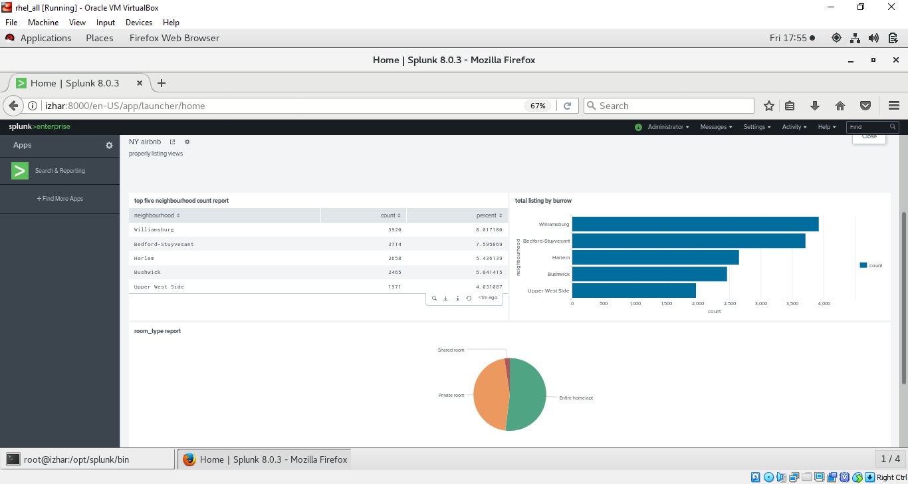
* Changing permission of dashboard go to dashboard option and click on edit option on NY Airbnb 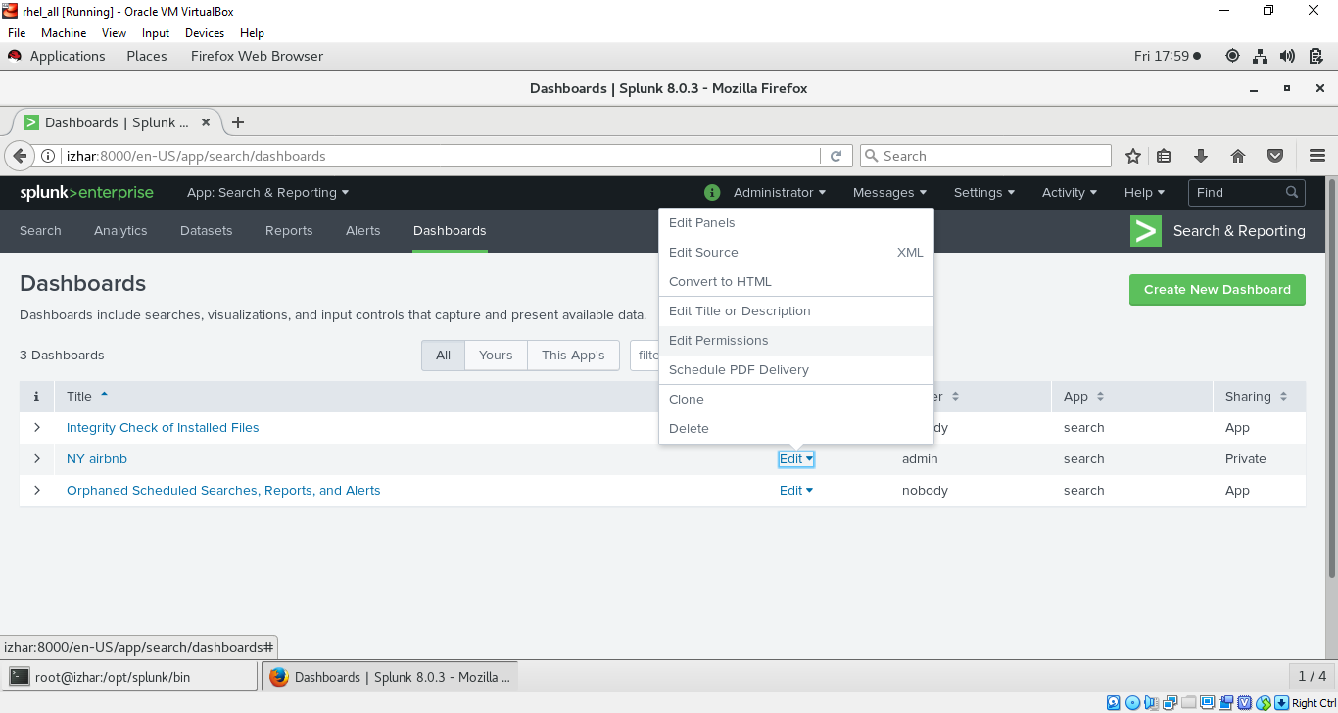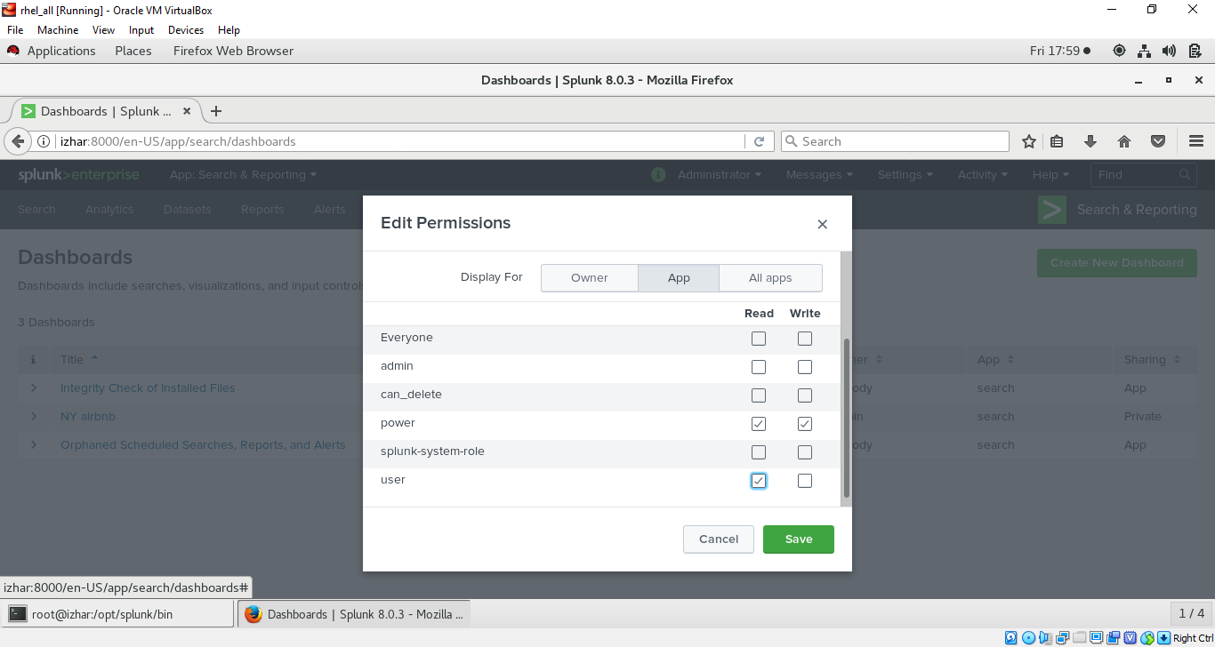
* Keep also in mind the same permission must be assigned on report else dashboard will not be able to load that reports which don’t have permissions
* Now cloning dashboard 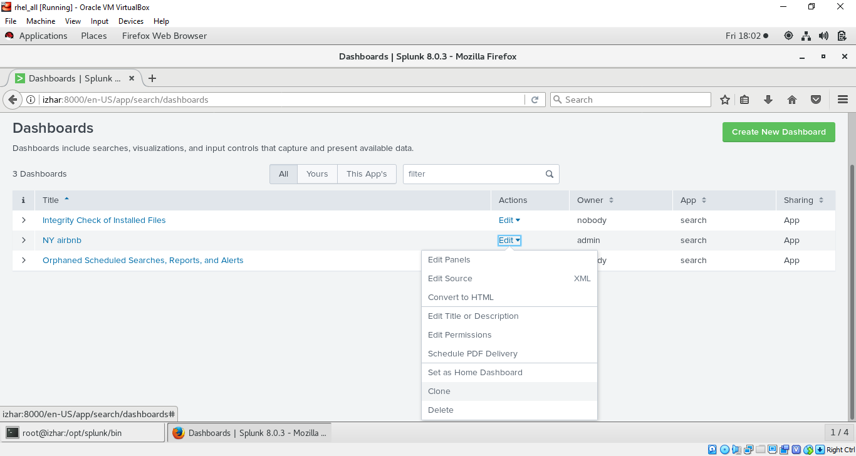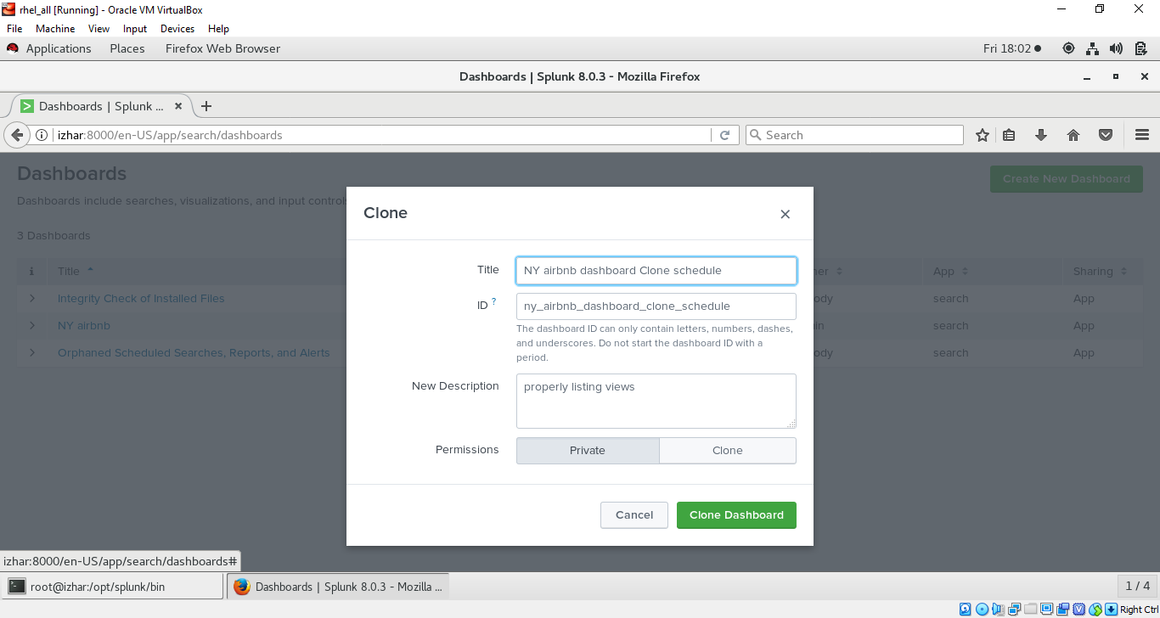
* Schedule dashboard by clicking on schedule
* Editing report or dashboard its better to go directly to dashboard and edit particular report there as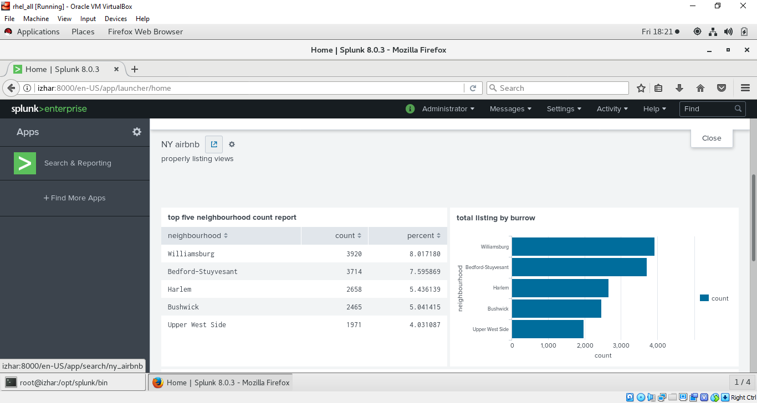
* Open dashboard click on edit 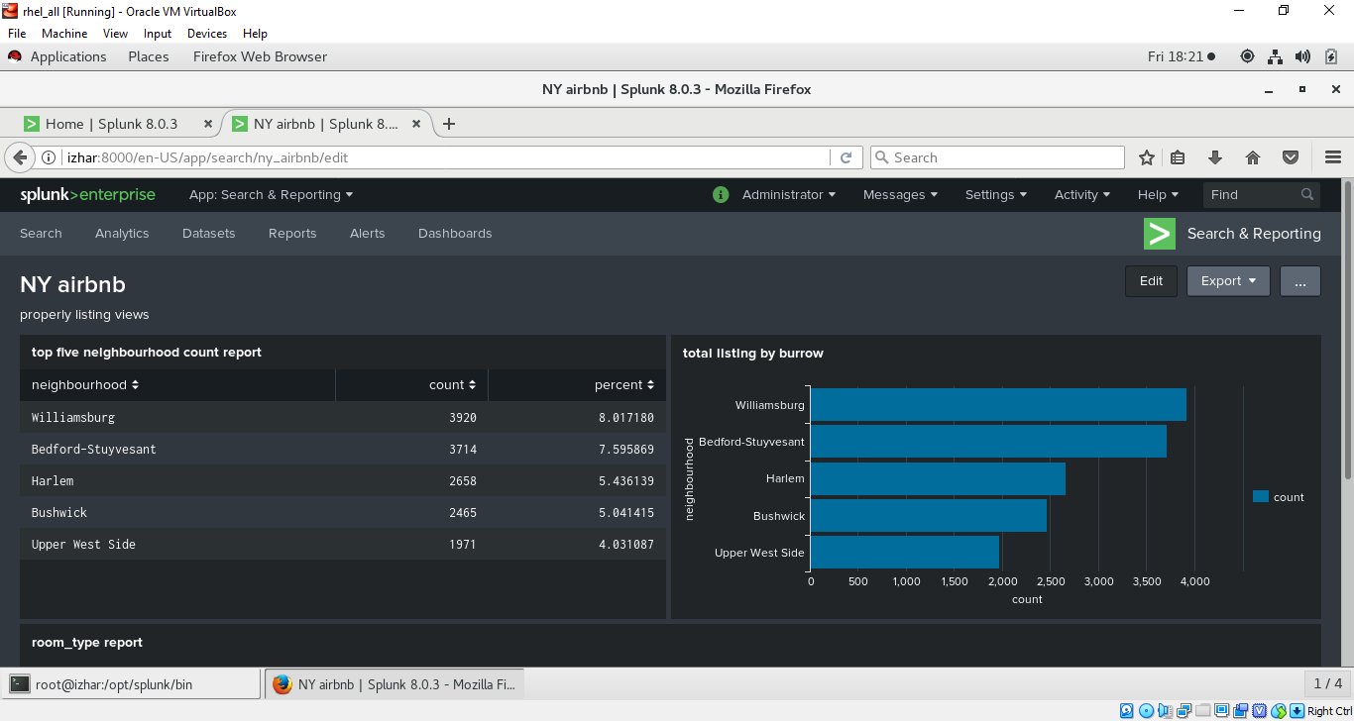
* Now you can edit particular report 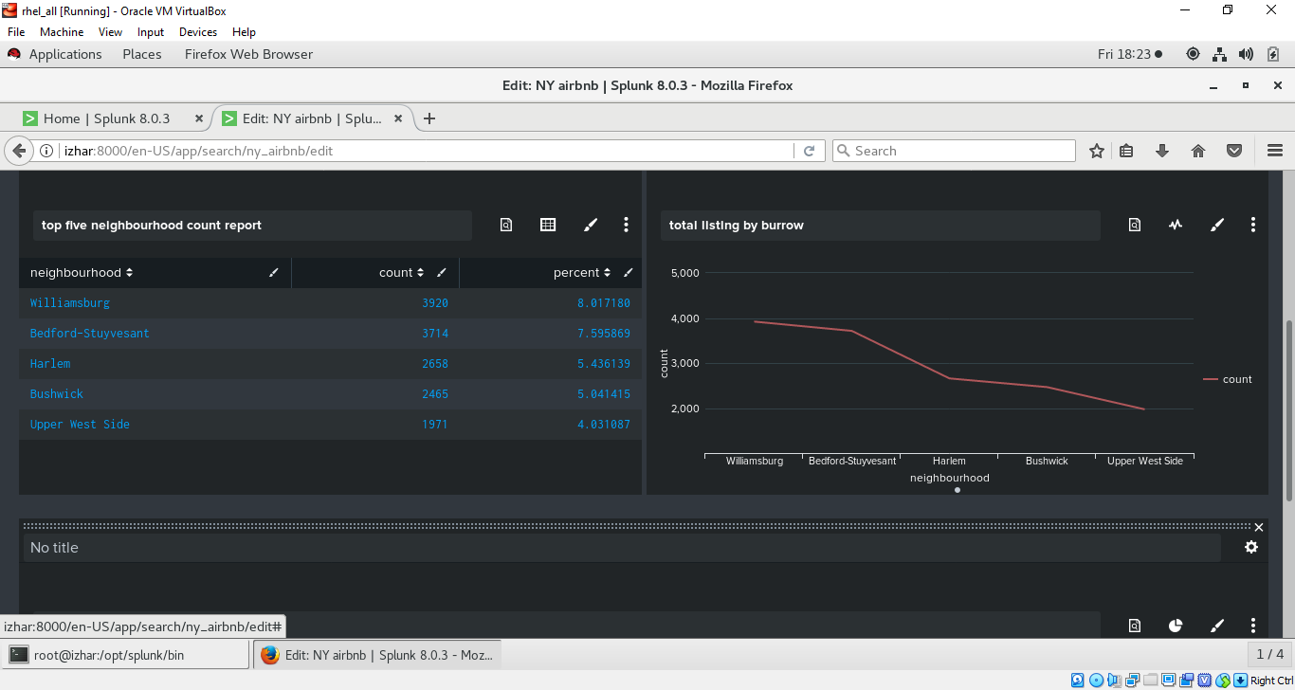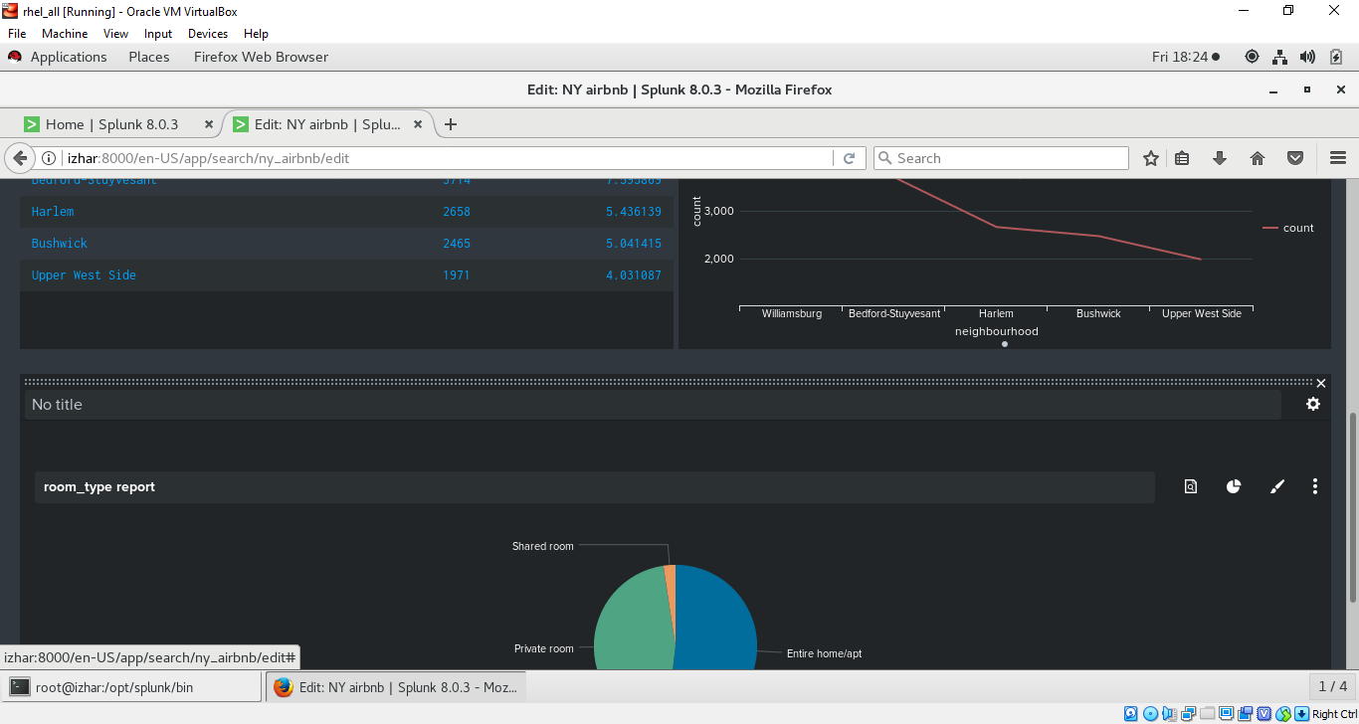
* After editing on home page our dashboard look like this 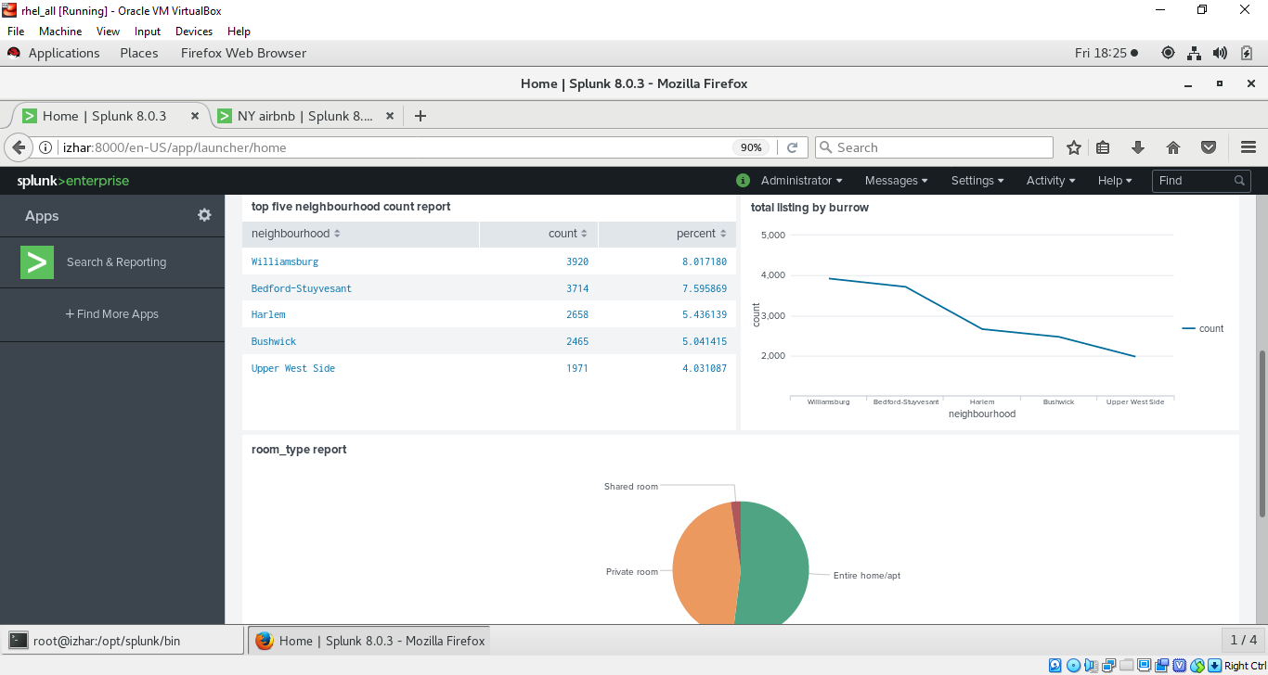
* DESIGNING ALERT IN SPLUNK :- ( go to reports click on open in search the report you want to choose) 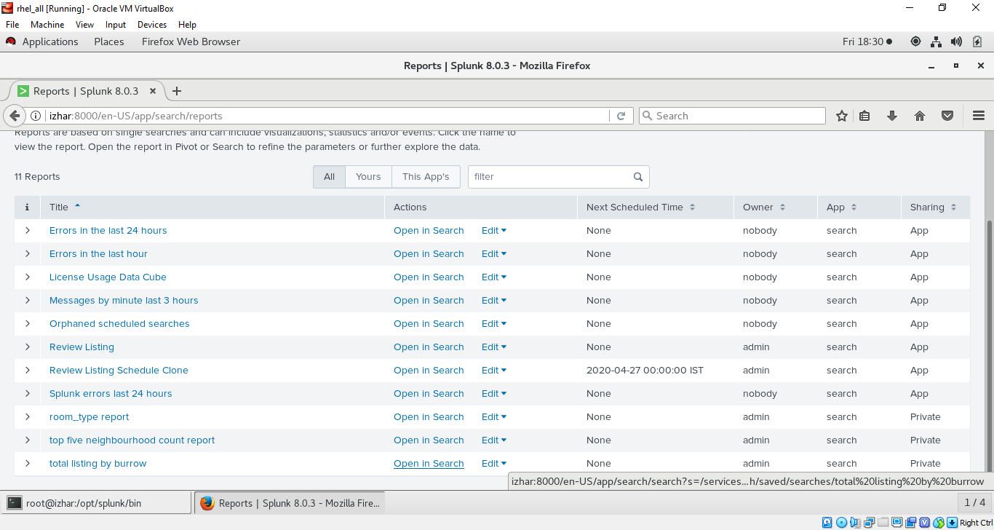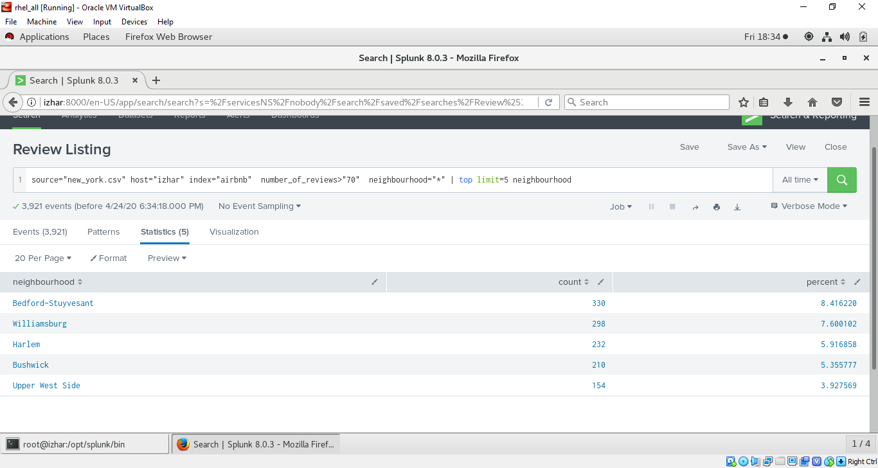
* Now change the search according to your own and then click on save as choose Alert : 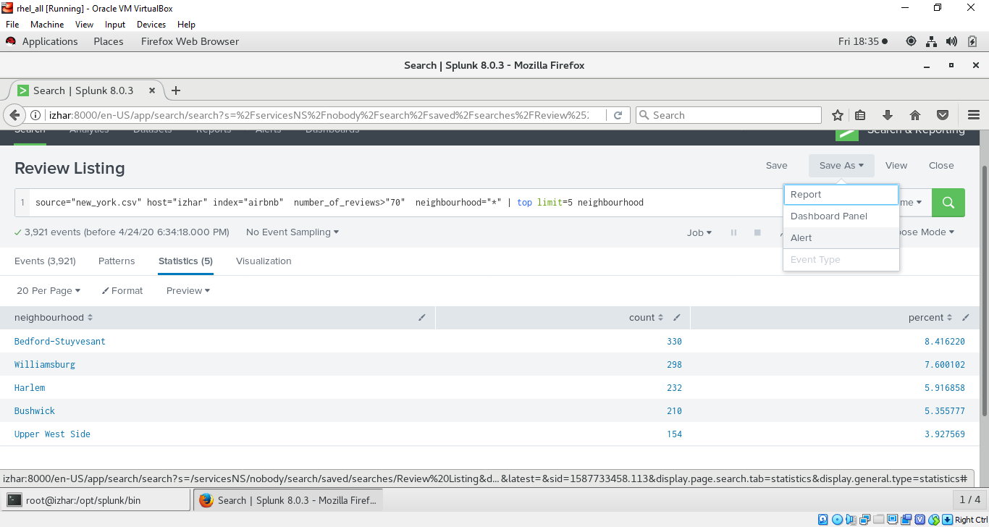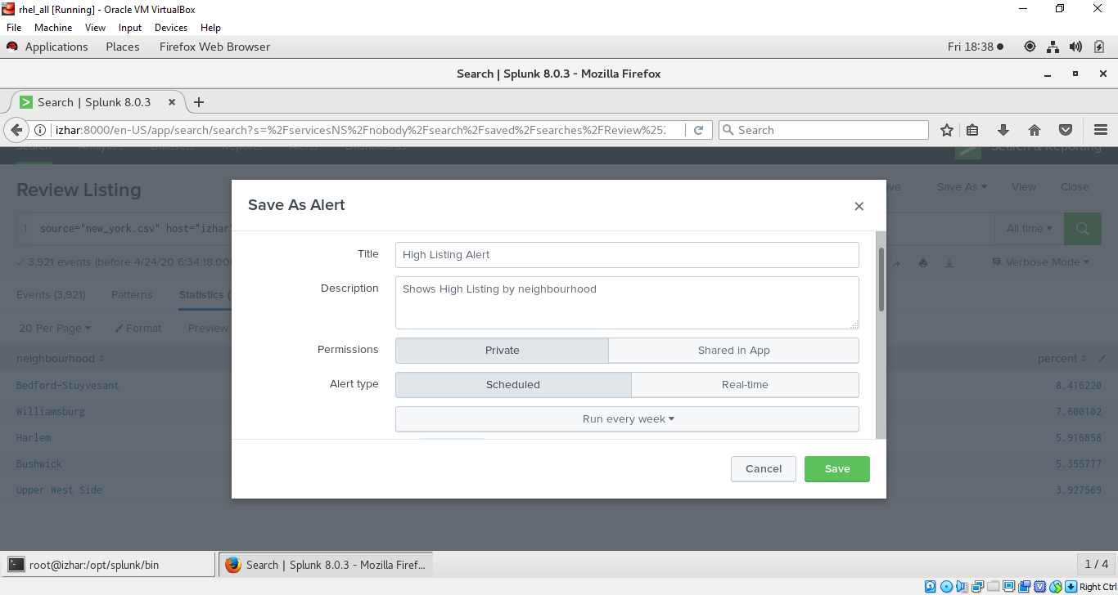
* Choose different option by scrolling and make target greater than current results in my case it is 3921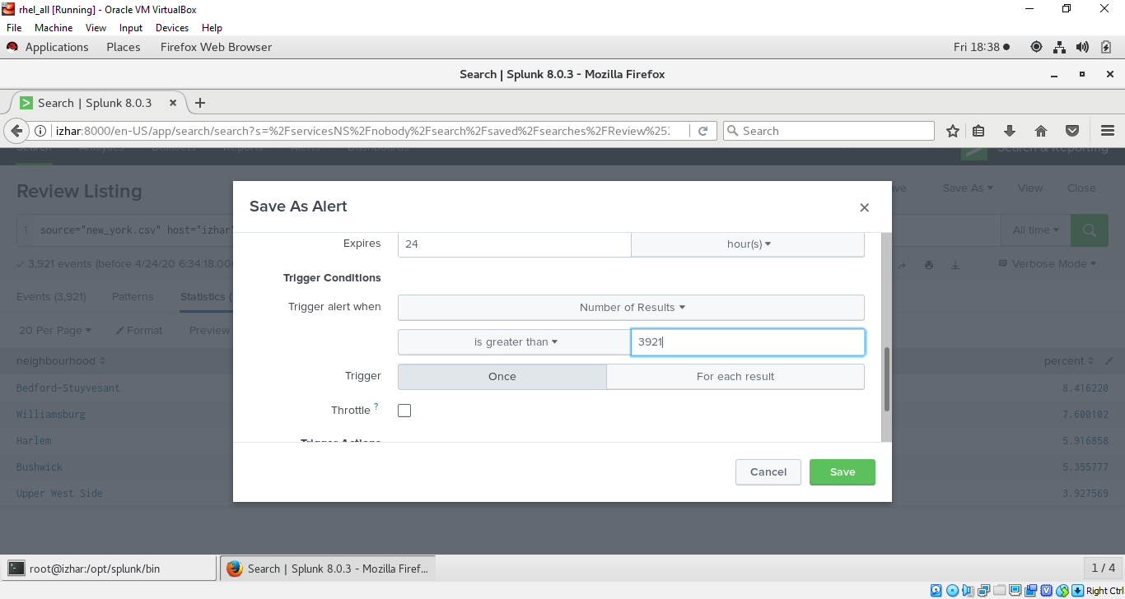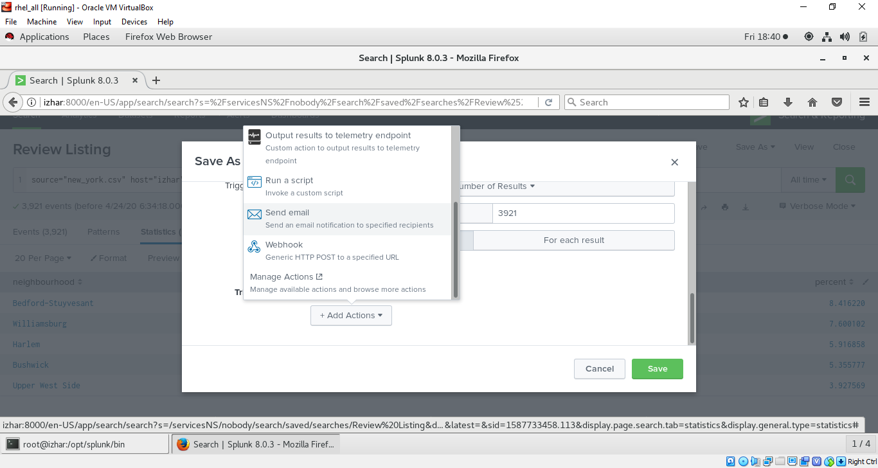
* Click add action and choose option send email (enter email and save)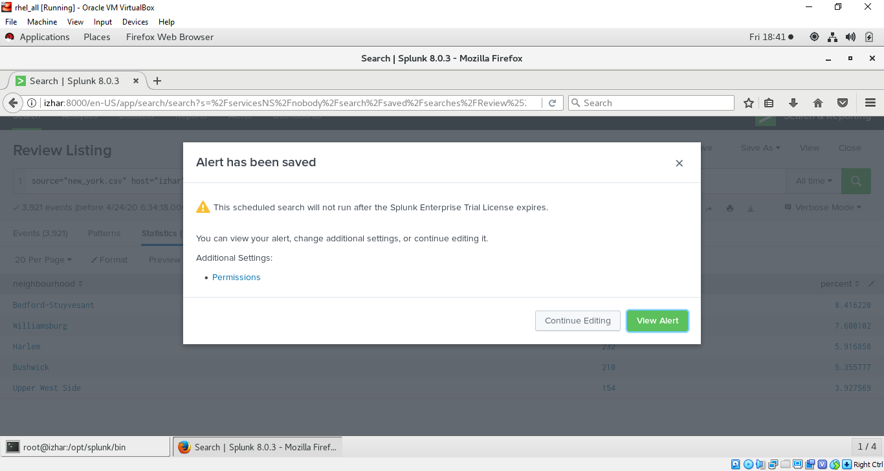
* Check permission if don’t have then give permission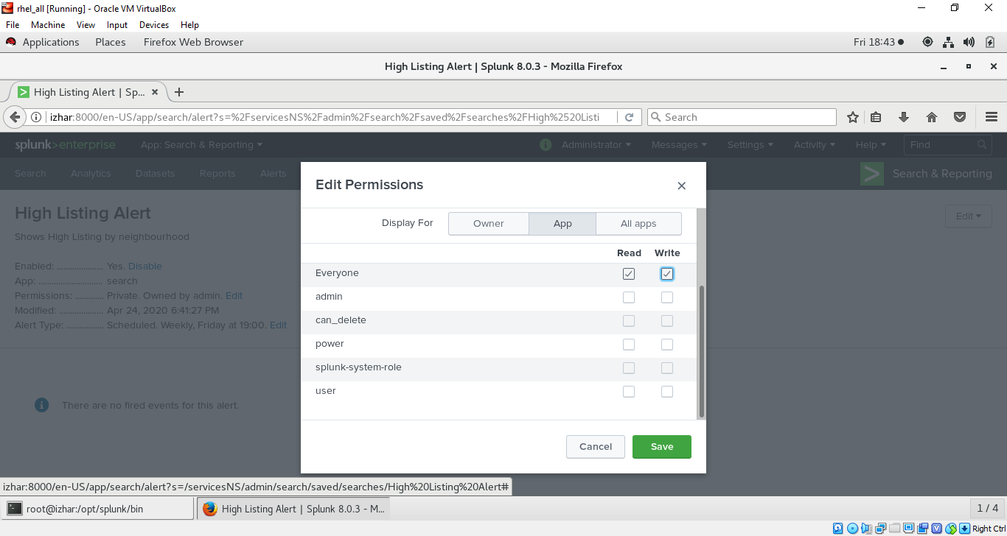
* Now go to alerts and check the alert is created or not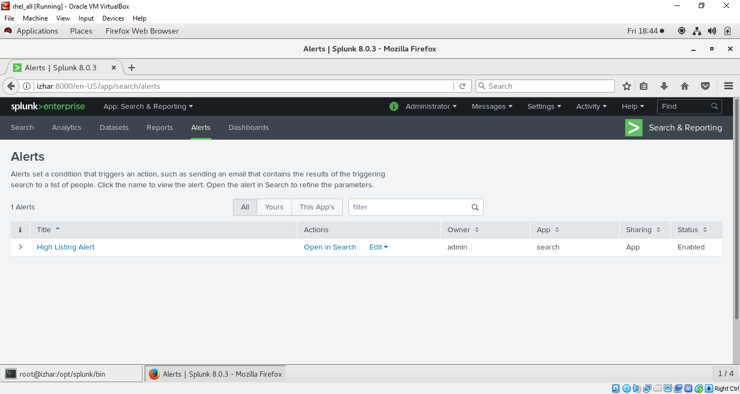
* Click on alert listed and this is how it look like